# **The DisplayApp is built with Angular8 and has HttpClient defined in a Service.**

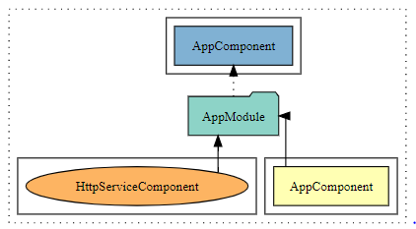

The purpose of this app is to receive and render data from the Express_Server.

This is how to install and run it.

1. Copy and unzip the DisplayApp_files.zip in a folder in your pc.

The file can be found on this GitHub URL:  
<https://github.com/keno1se/REST_Project/tree/master/DisplayApp/files>

2. Install node_modules

In command prompt/Visual studio open terminal and run  
  
**npm install** // creates the node_module

The DisplayApp_files folder should now looks like this.

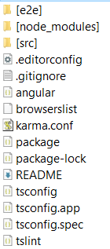

Start up the app with:

**npm start** // serves the app, open browser on localhost port 4200

If the Express server is not started the view will look like this.

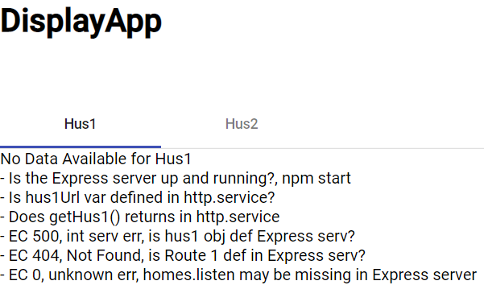

Start up the Express server by following the instruction: How to set up Express_Server.docx  
Instruction and server files can be found at GitHub:

<https://github.com/keno1se/REST_Project/tree/master/Express_Server>

When the server is up and running, the view looks like this:

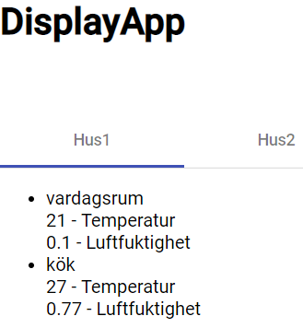

It shows data for Hus1 fetched from server with http GET method. Click on Hus2 to see associated data.

App documentation can be produced by using compodoc.

In terminal: **npm run compodoc**

The documentation folder is created and the browser is opened and render the documentation.

It’s a nice and tidy way to get familiar with the project.

**REST project overview**

Read more on how this app is interworking with the Express_Server; how the project is bootstrapped and see a SW flow example in: REST_Project_Overview.pdf  
The document is found here:

<https://github.com/keno1se/REST_Project>

**Testing**

Testing commands

- ng lint

- ng test

- ng e2e

**Note**. End to End test will fail if the app is up and running; app must be closed  
If receiving below error it means the the Express_Server is not started; Server must be started.

Failed to load resource: net::ERR_CONNECTION_REFUSED'

- Failed: unexpected alert open: {Alert text : Error Code: 0

Message: Http failure response for http://127.0.0.1:3000/homes/hus1/rooms: 0 Unknown Error}